BUDO JUNIOR SCHOOL
REMEDIAL WORK FOR TERM 1 2020 - SET TWO
MATHEMATICS FOR PRIMARY ONE

Name: _______________________________________________________________________________
Stream: ________________ Date: __________________________________________________
SECTION A
1. Count and write.
= ______

2. A collection of well defined things is a ______________.

3. Write the name of this number.
15 - _________________

4. Draw a kite.

5. Write this day correctly;
Tdayues - _____________________

6. Add:
3 + 5 = _____________

7. Which number is missing?
1 , 2 , _________, 4 , 5 , 6
8. Take away.
6 - 3 = _________

9. Circle the bigger numbers.
5 or 8

10. Name this set.

A set of ________________

11. Which number comes before?
a) _______, 2

12. Draw a symbol for empty set.

13. Circle the smaller number.
1 or 3.

14. Things found in a set are ___________________.

15. Count the beads.

= __________________
16. Write in figures.
eleven - ____________

17. 2 cups plus 3 cups equals ____________cups.

18. Write the number of the abacus.
T O

19. A basket and a stone which one is heavier? Circle it.
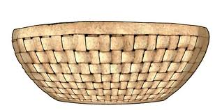basket 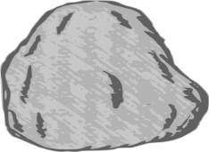 stone

20. Which number comes after?
5 , ____
SECTION B
21.a) Match words to numbers.
ten 7
thirteen 2
five 13
two 5
seven 10
22. Draw the beads.

2 = 5 =

23. Form small sets from the big one.


A set of ________________

A set of _______________

A set of __________________

24. Match the same sets.

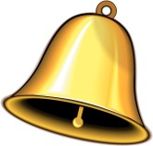

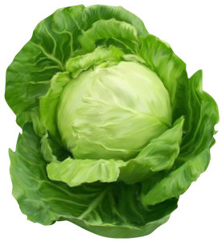

25. Add these numbers.
(a) 4 (b) 1 2
+ 3 + 3 3_
_________ ___________
c) Five girls plus three girls equals__________girls.

____________________________________________________________
26. Read and draw.
Three balls = Six eggs = Two girls =

27. Complete these sets using less or more.
X Y

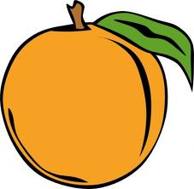

- Set X has ________________members than set Y.
- Set Y has ________________ members than set X.
- Set X has ________________ members.

28. Fill in the missing numbers.
(i) 3 , ____ , 5 , 6 , 7 , ____ (ii) 9 , 10 , ____ , 12 , 13
(iii) 14, 15, 16, ______ , 18 (iv) 18 , _____ , 20

30. Take away:
6 - 3 = 5 - 1 = 4 - 2 =

29. Add these objects:

+ =

+ =

+ =

31. Use shorter and taller.
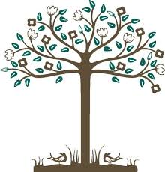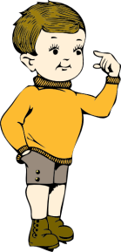

- A tree is ______________ than a stick.
- A boy is _____________ than a stick
- A stick is ________________ than a tree.

32. Write empty set or not empty set.
(a) A set of girls with tails. - _______________________________
(b) A set of boys with eyes. - ________________________________

(c ) Draw these sets.
(i)A set of three balls. (ii) A set of 3 pencils. (iii) A set of 2 cups.

